**Class type:**

|  |  |  |
| --- | --- | --- |
| Comic | College Prep | Watercolor |
| Acrylic | Drawing | Oil |
| Teen Art | mix media | Pastel |

**Colorest Art Supplies Fall Art Class Schedule www.colorestartsupplies.com**

**2012**

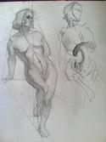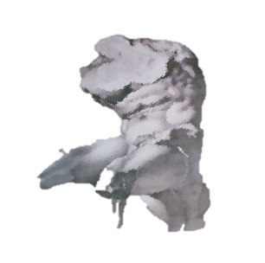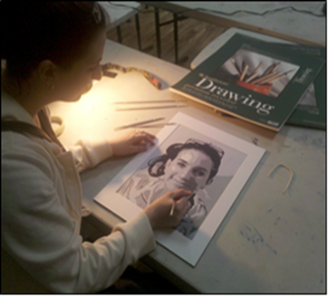

**COMICS**

** Comic Book Techniques with Professional Artist Sean Pryor**

***Wednesday 4-6pm September 12- November 14***

Professional Cartoonist Sean Pryor shows you how the inner workings of visual storytelling in movies and comics are strikingly similar; while also showing how each medium has their own exclusive tricks. Classes will include demonstrations that anyone can pick up and run with on the spot. From thumbnails to story-boards; from sounds FX lettering to sound tracks come see how both mediums work to tell memorable stories. **10 week course $260 plus materials.**

**Life Drawing with Professional Artist Scott Nickerson**

***Fridays 10am-Noon September 14- October 12***

Figure drawing-- working from live nude model on short poses and long poses all drawing materials welcome. Main focus will be on capturing the gesture, structure, and rendering the form using lights and darks. Individual instruction will be given as well as side demonstrations.

**5 week course $135 (plus small model fee to be split by class) plus materials**

**Continued on reverse side**

More classes, workshops and events are being added all the time. Please follow us on Facebook @ Colorest Art Supplies or sign up for our email updates.

To register for any classes or workshops please call Colorest at 732-741-0001 or stop by. Seating is limited on every class please register early to secure your place.  
**COLOREST ART SUPPLIES 160 NEWMAN SPRINGS RD. E, RED BANK NJ 07701 732-741-0001**

**www.ColorestArtSupplies.com**

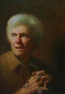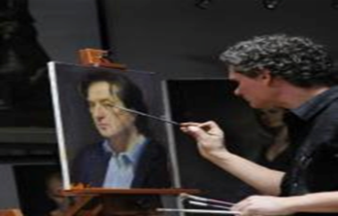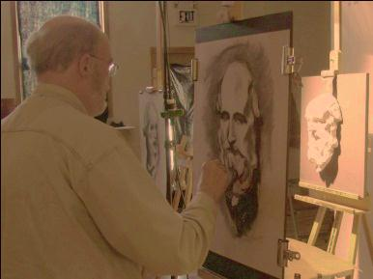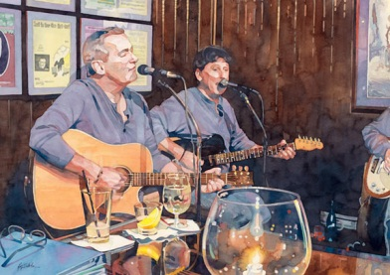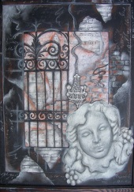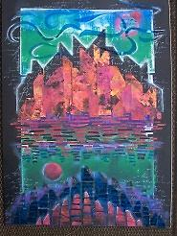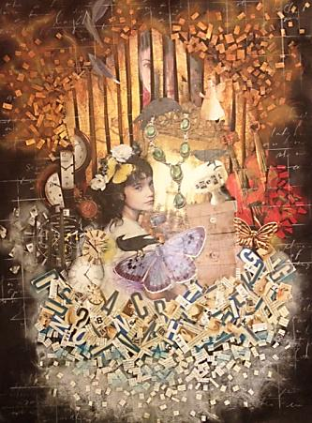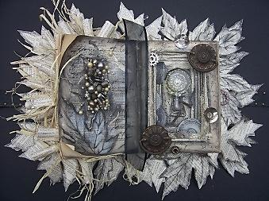

**NEw**!

**Classical Drawing of Cast Sculptures w/Professional Artist Scott Nickerson**

**Tuesday 10am- Noon September 11- November 13**

Learn how to systematically draw from cast heads of famous ancient sculptures. A classical atelier approach to drawing is the cast drawing. These most often are anatomical plaster casts. Plaster is white so there is no color distracting the student. Students are able to see the form better while looking at a monochrome reference.. **10 week course $290 plus materials**

  **Creating a College Portfolio with Fine Artist Ken Stetz**

***Thursdays 4:30-6:3pm September 13- November 15***

Learn advanced university level drawing and media techniques as you create original art that will showcase your artistic strengths and individuality. Ken Stetz is a widely published illustrator and a gallery represented fine artist with extensive experience dealing with many major art universities. The success of his past students speaks for itself. Carnegie Mellon, UArts, FIT, SVA, Syracuse, Kutztown, SCAD, and Tyler School of Art at Temple University are all programs that have accepted students from his portfolio classes.

Colorest students will receive a 20% discount on art materials and from framing department for the duration of your class. **10 week course $285.00 plus materials**

**Techniques-Pencils,Pen,Brushes w/ Fine Artist Illustrator Ken Stetz**

***Thursdays 10am-Noon September 13 – November 15***

This class will cover the fundamentals of good drawing as well as studying specific techniques when using pencils, charcoal, pens and water based mediums. Explore landscapes, structures in landscapes, bodies of water, and figures as we find subjects from the area around us. This class will have some sessions on location. Students receive a 20% discount on art materials and from the framing department for the duration of course. **10 week course $270 plus materials**

**  Teens Printmaking, Collage & Altered Books/Artist Carla Valentino**

***Tuesdays 4-6pm September 11- November 13***

This class offers the student the opportunity to create multi-colored reduction prints using easily cut linoleum and a variety of inks.  Additionally, collage media such as newspaper and magazine text and other ephemera will be added to the print to create a unique work. Drawing and painting media may also be incorporated. **10 week course $260 plus materials**

      Also, an altered book project will be included to experience a 3D/ assemblage technique while again employing a variety of media with a re-purposed book as "canvas."

      The work of masters as well as contemporary artists working in each genre will be examined throughout.   No experience necessary!

**Adult Collage Experiments with Professional Artist Carla Valentino**

***Wednesdays 7-9pm September 12- November 14***

This course examines collage techniques based on significant works by masters of collage such as

Picasso, Joseph Cornell, Robert Rauschenberg, Romare Bearden, Jasper Johns as well as many contemporary artists working in the genre. Taking inspiration from the ways these artists pushed the boundaries of representation and use of materials will show students how to create their own collages by transforming fragmented, combined and repurposed objects and images. 2d & 3d projects will be included. **10 week course $270 plus materials**

**10 week course cost $270 plus materials**

**Back to Basics- Portrait Oil Painting with Professional Artist Scott Nickerson**

***Wednesdays 10am-Noon September 12-November 14***

Instructor Scott Nickerson breaks down the basic foundation to a great portrait painting. From materials to use, to step by step approach on how to get the quality results you are looking for while painting a portrait. Colorest students receive a 20% discount on art materials and from our picture framing department. **10 week course $270 (plus model fees due on first day of class- models fees split by entire class) plus materials**

**Colorest Art Supplies Fall Art Class Schedule www.colorestartsupplies.com**

**2012**

**Class type:**

|  |  |  |
| --- | --- | --- |
| Comic | College Prep | Watercolor |
| Acrylic | Life Drawing | Oil |
| Teen Art | Drawing/ mix med | Pastel |

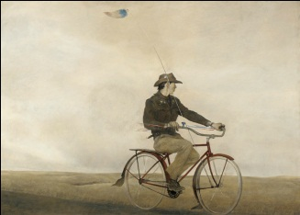

**Masters’ Techniques-** **Pencils to Paintbrushes Artist/ Illustrator Artist Ken Stetz**

*Thursdays 7pm-9pm September 13- November 15*

Learn about some of America’s greatest artist’s such as Homer, Sargent, Wyeth, Cassatt as we study their techniques in graphite and charcoal, colored pencils and pastel, watercolor and ink tense pencils, and painting in water based mediums. Use their work to influence your own original work to create studies from their master still life’s, landscapes, and portraits and children's portraits. Reproductions will be provided. **10 week course $270 plus materials**

** Weekends with Mario with Professional Artist Mario A. Robinson**

***Saturday 11am-2pm August 18 - September 8 & October 6 - November 10***

This class will focus on painting the figure. Participants will be offered the option to work in watercolor or pastel. Students can expect individual critiques and an intense focus on materials. The goal is to approach the portrait with a high level of creative skill as well as a deep appreciation for the human experience. The class is designed for all levels. Beginners will receive a comprehensive introduction, while advanced students will be given instruction on a higher level of technical proficiency. There will be demonstrations by the instructor throughout the duration of the classes. **4 week course $150 / 6wk $225 plus materials**

More classes, workshops and events are being added all the time.

Please follow us on Facebook @ Colorest Art Supplies or sign up for our email updates.

To register for any classes or workshops please call Colorest at 732-741-0001 or stop by. Seating is limited on every class please register early to secure your place.  
**COLOREST ART SUPPLIES 160 NEWMAN SPRINGS RD. E, RED BANK NJ 07701**

**www.ColorestArtSupplies.com**

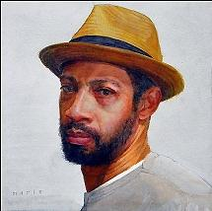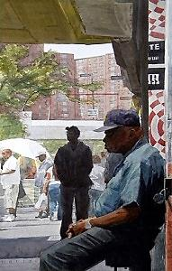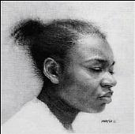

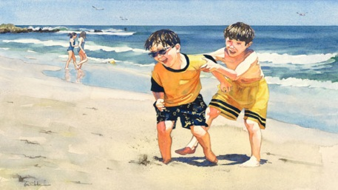

**Painting in Watercolor with Fine Artist/ Illustrator Ken Stetz**

***2 Times Available: Monday 10am-12pm; Tuesdays 7pm-9pm Sept. 10/11 – Nov.12/13***

Study the techniques used to create strong vibrant watercolor paintings. The class will cover composition, drawing on watercolor paper, light and shadow, color mixing, color application, controlling edges and managing your palette. Explore subject matter such as landscapes, seascapes, and people. Beginners to advanced painters are welcome. Instructor Ken Stetz works with students on an individual basis. Work from your own material or from pre-worked studies provided by Ken.**10 week course $270 plus materials**

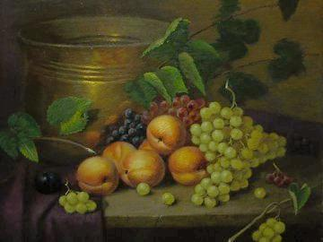

**Pastel Painting with professional Artist Salomon Kadoche**

***Thursdays 10am-1pm September 13- October 11***

This is a class for people interested to know anything about pastels. Whether you are an experienced pastel artist or somebody completely new to pastels, you'll find this very talented instructor SALOMON KADOCHE interesting with lots of useful information and advice on how to create beautiful pastels. Mr. Kadoche was born in Casablanca, Morocco and has dedicated his life to perfecting his craft and producing quality work. Now settled in Monroe he explores undiscovered places in the Garden State and continues to produce breathtaking renditions of realism. **5 week course $260 or $60 per individual class plus materials**

**\*\*\*\*\* New instructor and workshop schedule for fall coming soon! \*\*\*\*\***  
 *Are you on our email list?* Go to our website to register for updates on classes, workshops, demonstration events and sales!

*Follow us on facebook at Colorest Art Supplies!*

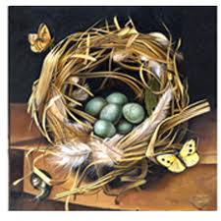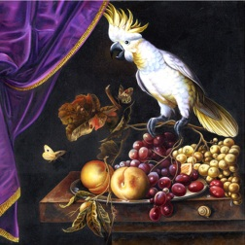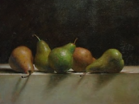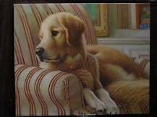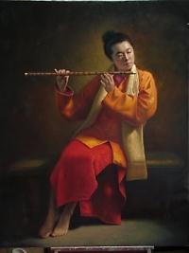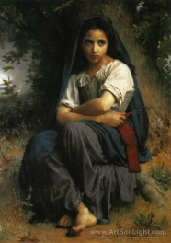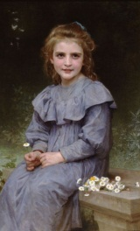

**Painting Bouguereau's with Professional Artist Scott Nickerson**

***Tuesdays 1pm-3pm September 11 - November 13***

In this class instructor Scott Nickerson will give students a choice of 1 of 2 reference pictures of a Bouguereau painting. You will then copy this painting in oil and discover the magic of this Old Master. Colorest students receive a 20% discount on art materials and from the picture framing department for the duration of their class. **10 week course $305 plus materials**Choose from pictures to right when registering #1 Daisies 20x30 or 2#Red Ribbon 20x28

**New Instructor!**

**All Colorest students receive a 20% discount on all materials and custom framing for the duration of their class!**

 **High Focus Acrylic Painting with Professional Artist Cheryl Griesbach**

**Tuesdays 7-9pm  September 11- November 13**

This course is designed for beginners and experienced painters alike.  The class will explore methods used to create vivid and detailed paintings that can duplicate what oils do with the advantage of glazing and building up layers by techniques that were first developed when acrylic paintingwas introduced. This course will help you develop these methods and gain skills to realize your artistic vision. Group critiques and one  on one instruction will help inform and assist your process to attain your goals.

**10 week course $270 plus materials**

**Oil Painting Techniques with Professional Artist Scott Nickerson**

***3 times available Mondays 7-9pm September 10 - November 12***

***Wednesdays 1-3pm or 7-9pm September 12- November 14***

Scott Nickerson’s most popular class! Classic oil painting with Scott Nickerson. Learn classic oil painting techniques used by the great masters. Still Life, Landscape, Trompe l'oeil and portrait can all be explored in this class. Beginner to advance is welcome.

**10 week course $270 plus materials**